SIMATS ENGINEERING
ASSESSMENT TOOL 1

COURSE CODE: CSA1402 COURSE NAME: Compiler Design

COURSE OUTCOME COVERED

CO2: Construct top-down and bottom up parsers using CFG for parsing conflicts and error recovery for efficient syntax tree generation. (BL3)

Assessment Tool Weightage: 40%

QUESTIONS:4 Total Marks:50
Annexure A

DESIGN TASK

Code of Conduct:

I KAMALESH V (192421294) (Name / Reg No) certify that this submission is my original work and that I have adhered to the guidelines specified for this assessment.
I understand that any violation of academic integrity rules will result in disciplinary action.

Signature of the student:
KAMALESH V

Course Faculty :Dr.N.DEEPA

Annexure A
DESIGN TASK

PROGRAM 1:
#include <stdio.h>
#include <string.h>

char input[50];
char stack[50];
int top = -1;
int ip = 0;

void push(char c) {
stack[++top] = c;
}

char pop() {
return stack[top--];
}

char peek() {
return stack[top];
}

void printStack() {
for (int i = 0; i <= top; i++)
printf("%c", stack[i]);
}

int main() {

printf("Grammar:\n");
printf("E->TA\n");
printf("A->+TA|e\n");
printf("T->FB\n");
printf("B->*FB|e\n");
printf("F->(E)|i\n\n");

printf("Enter input (use i for id): ");
scanf("%s", input);

strcat(input, "$");

push('$');
push('E');

printf("\nStack\t\tInput\t\tAction\n");

while (top != -1) {

printStack();
printf("\t\t%s\t\t", input + ip);

char x = peek();
char a = input[ip];

if (x == a && x == '$') {
printf("Accepted\n");
break;
}

else if (x == 'i' || x == '+' || x == '*' || x == '(' || x == ')' || x == '$') {

if (x == a) {
pop();
ip++;
printf("Match %c\n", a);
} else {
printf("Error\n");
break;
}
}

else if (x == 'E') {
if (a == 'i' || a == '(') {
pop();
push('A');
push('T');
printf("E->TA\n");
} else {
printf("Error\n");
break;
}
}

else if (x == 'A') {
if (a == '+') {
pop();
push('A');
push('T');
push('+');
printf("A->+TA\n");
} else if (a == ')' || a == '$') {
pop();
printf("A->e\n");
} else {
printf("Error\n");
break;
}
}

else if (x == 'T') {
if (a == 'i' || a == '(') {
pop();
push('B');
push('F');
printf("T->FB\n");
} else {
printf("Error\n");
break;
}
}

else if (x == 'B') {
if (a == '*') {
pop();
push('B');
push('F');
push('*');
printf("B->*FB\n");
} else if (a == '+' || a == ')' || a == '$') {
pop();
printf("B->e\n");
} else {
printf("Error\n");
break;
}
}

else if (x == 'F') {
if (a == 'i') {
pop();
push('i');
printf("F->i\n");
} else if (a == '(') {
pop();
push(')');
push('E');
push('(');
printf("F->(E)\n");
} else {
printf("Error\n");
break;
}
}
}

return 0;
}
Output:
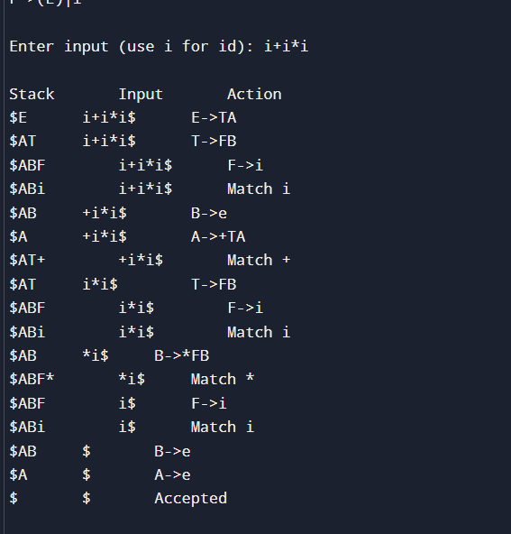

PROGRAM 2:
#include <stdio.h>
#include <string.h>

char input[50], stack[50];
int top = -1, i = 0;

void printState(char action[]) {
printf("%-15s %-15s %s\n", stack, input + i, action);
}

int main() {
printf("Grammar:\n");
printf("E -> E+E\n");
printf("E -> E*E\n");
printf("E -> i\n\n");

printf("Enter input (use i for id): ");
scanf("%s", input);

strcat(input, "$");

printf("\n%-15s %-15s %s\n", "Stack", "Input", "Action");

while (1) {

// Shift
stack[++top] = input[i++];
stack[top + 1] = '\0';
printState("Shift");

// Reduce i -> E
if (top >= 0 && stack[top] == 'i') {
stack[top] = 'E';
printState("Reduce E->i");
}

// Reduce E*E -> E (Higher precedence)
while (top >= 2 &&
stack[top] == 'E' &&
stack[top - 1] == '*' &&
stack[top - 2] == 'E') {

top -= 2;
stack[top] = 'E';
stack[top + 1] = '\0';
printState("Reduce E->E*E");
}

// Reduce E+E -> E
while (top >= 2 &&
stack[top] == 'E' &&
stack[top - 1] == '+' &&
stack[top - 2] == 'E') {

// Delay reduction if next input is '*'
if (input[i] == '*')
break;

top -= 2;
stack[top] = 'E';
stack[top + 1] = '\0';
printState("Reduce E->E+E");
}

// Accept
if (strcmp(stack, "E") == 0 && input[i] == '$') {
printState("Accept");
printf("\nString Accepted\n");
break;
}

if (input[i] == '$' && strcmp(stack, "E") != 0) {
while (top >= 2 &&
stack[top] == 'E' &&
stack[top - 1] == '+' &&
stack[top - 2] == 'E') {

top -= 2;
stack[top] = 'E';
stack[top + 1] = '\0';
printState("Reduce E->E+E");
}

if (strcmp(stack, "E") == 0) {
printState("Accept");
printf("\nString Accepted\n");
} else {
printf("\nString Rejected\n");
}
break;
}
}

return 0;
}
OUTPUT:
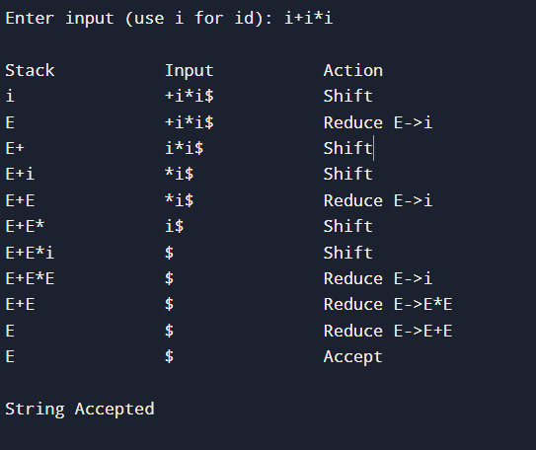

PROGRAM 3:
#include <stdio.h>
#include <string.h>
char input[100];
char stack[100];
int top = -1, ip = 0;
void push(char x)
{
stack[++top] = x;
}
void pop()
{
top--;
}
void displayStack()
{
for (int i = 0; i <= top; i++)
printf("%c", stack[i]);
}

int main()
{
printf("Grammar after removing Left Recursion:\n");
printf("S -> TA\n");
printf("A -> +TA | e\n");
printf("T -> FB\n");
printf("B -> *FB | e\n");
printf("F -> (S) | i\n\n");

printf("Enter input (use i for id): ");
scanf("%s", input);

strcat(input, "$");

push('$');
push('S');

printf("\n%-15s %-15s %s\n", "Stack", "Input", "Action");

while (top >= 0)
{
displayStack();
printf("\t\t%s\t\t", input + ip);

char X = stack[top];
char a = input[ip];

// Accept
if (X == '$' && a == '$')
{
printf("Accepted\n");
printf("\nString Accepted\n");
break;
}

// Match terminals
if (X == 'i' || X == '+' || X == '*' || X == '(' || X == ')' || X == '$')
{
if (X == a)
{
pop();
ip++;
printf("Match %c\n", a);
}
else
{
printf("Error\n");
break;
}
}

// S -> TA
else if (X == 'S')
{
if (a == 'i' || a == '(')
{
pop();
push('A');
push('T');
printf("S->TA\n");
}
else
{
printf("Error\n");
break;
}
}

// A -> +TA | e
else if (X == 'A')
{
if (a == '+')
{
pop();
push('A');
push('T');
push('+');
printf("A->+TA\n");
}
else if (a == ')' || a == '$')
{
pop();
printf("A->e\n");
}
else
{
printf("Error\n");
break;
}
}

// T -> FB
else if (X == 'T')
{
if (a == 'i' || a == '(')
{
pop();
push('B');
push('F');
printf("T->FB\n");
}
else
{
printf("Error\n");
break;
}
}

// B -> *FB | e
else if (X == 'B')
{
if (a == '*')
{
pop();
push('B');
push('F');
push('*');
printf("B->*FB\n");
}
else if (a == '+' || a == ')' || a == '$')
{
pop();
printf("B->e\n");
}
else
{
printf("Error\n");
break;
}
}

// F -> i | (S)
else if (X == 'F')
{
if (a == 'i')
{
pop();
push('i');
printf("F->i\n");
}
else if (a == '(')
{
pop();
push(')');
push('S');
push('(');
printf("F->(S)\n");
}
else
{
printf("Error\n");
break;
}
}
}

return 0;
}
OUTPUT:
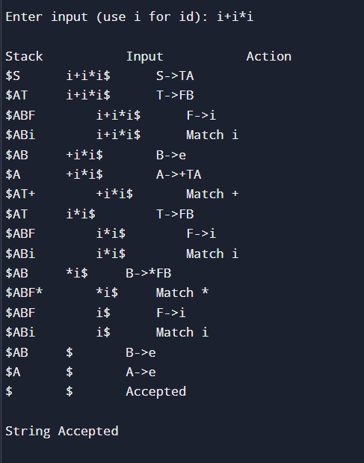

RUBRICS FOR CALCULATION:

Criteria | Weightage | Level 4 – Exemplary | Level 3 – Proficient | Level 2 – Developing | Level 1 – Beginning
Understanding of Concepts | 20 | Demonstrates thorough understanding and integrates multiple concepts effectively | Good understanding with proper integration of most concepts | Basic understanding with partial integration | Poor understanding with no integration
Design & Implementation | 25 | Well-designed solution with systematic and optimal implementation | Correct design with minor issues | Basic design with errors or inefficiencies | Incorrect or incomplete design
Parser/Algorithm Construction | 20 | Accurate construction of parser/algorithm with complete logic | Mostly correct construction with minor errors | Partial construction with missing logic | Incorrect or incomplete construction
Analysis & Validation | 15 | Insightful analysis with correct validation and justification | Good analysis with reasonable justification | Basic analysis with limited validation | Poor or incorrect analysis
Documentation & Presentation | 20 | Well-structured documentation with diagrams, steps, and clarity | Organized documentation with required details | Basic documentation with missing details | Poor or incomplete documentation

Program4:
